19 Belay High Ropes Rescue (Buddy or Cut-Away)

How to Get a Manager Check-Off
Attend a Rescue Training to learn how to belay using a rescue 8. To get checked off, attend a rescue training and show competency.

Procedure Details
The role of the rescue belayer is:
- Provide the “toe to toe” check on the rescuer before he/she climbs.
- As the rescuer is working he/she will be verbalizing everything that he/she is doing. The rescue belayer will repeat everything the rescuer is saying.
- Watch the rescuer to make sure he/she is doing everything right.
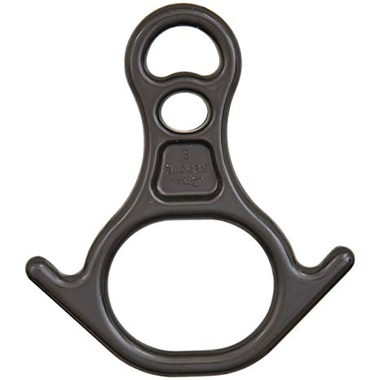
- Belay for the rescuer and participant.
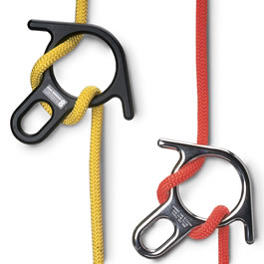
Rescue belayers will use a Rescue 8 (fig. 1) and thread the rescue rope through (fig. 2). Connect to your harness with a carabiner and belay as normal. Have an anchor (preferably a staff member) ready and nearby, just in case. If the rescue requires a cut away, note that while you’ll have the weight of two people on your rope, the system will use two rescue 8 to increase friction and you and an anchor will be enough to keep you grounded.
Fig. 1
Fig. 2

