5 Helmets

How to Get a Manager Check-Off
A check off is not currently required.

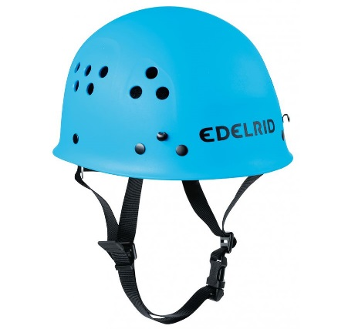
Procedure Details
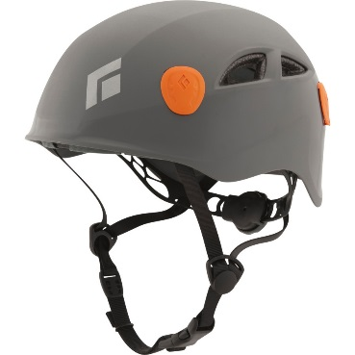
Currently, the Peak Adventures Challenge Center is using the Edelrid Ultralight Climbing Helmet (pictured on the left) and the Black Diamond Half Dome Helmet (pictured on the right). We have a small and large version of each helmet. The Edelrid small helmet is light blue and the large is white. The Black Diamond small helmet is grey and the large is green. The Black Diamond helmets are slowly being phased out because they are meant to be used for personal use, not the repetitive amount we put them through. They are wearing out quicker than expected. Both helmets tighten differently so while we are still using both on the course, it is important to understand how both of them work.
All helmets are stored in plastic tubs in the Rope Shed. At the end of each day, any helmet that was used must be checked that it is still in working condition and sprayed with a disinfectant before being put in the plastic tubs.
Standards for Both Helmets
- Participants must wear helmets when engaging in any activity over 6 feet above the ground.
- A facilitator must check each participant’s helmet to ensure a proper fit. Checking the helmet is part of the Toe to Toe Check.
Fitting Both Helmets
- Adjust the helmet so it is fairly loose for the participant to put on comfortably.
- Hair that hangs over the face needs to be pushed back. Ponytails may need to be adjusted.
- The helmet needs to sit directly on top of the head – not so far forward that it is across the bow and back like a bonnet. If positioned properly, the helmet will protect the head.
- Clip in the chin strap after the basket of the helmet has been adjusted. See below for specific instructions for adjust the basket for each helmet.
Main Points of the Edelrid Hemet
- Front of the helmet – labeled with “Edelrid”
- Adjustable Strap in the back of the helmet to tighten the basket – When tightened the helmet should not shift of slip off. Always make sure the buckle on the strap is properly closed.
- Chin strap – When connected below the chin, it should not feel like it is choking the participant nor should it come up over the chin.
Main Points of the Black Diamond Helmet
- Front of the helmet – labeled with the Black Diamond logo
- Adjustable dial in the back of the helmet to tighten the basket – When turned to the right, the helmet tightens and you can hear a loud clicking. When tightened correctly the helmet should not shift of slip off.
- Chin strap – When connected below the chin, it should not feel like it is choking the participant nor should it come up over the chin.

