VIRTUAL INITIATIVE: Traffic Jam

GOAL:
- To get all team members to cross traffic.

SET-UP:
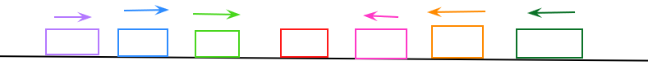
- While your small group is on break, create a white board in Zoom that looks similar to the following screen shot:
- This can take a few minutes so setting this up during a break prevents your group from getting restless. There needs to be one space and color coordinated arrow per team member. Also, one space in the middle without an arrow.
  - You could also do this in a Word doc or other format.

STORY:
- Each one of these arrows are a cars trying to get through traffic. The cars on the left are trying to get up to Folsom and the cars on the right are trying to get to downtown and it is Friday!
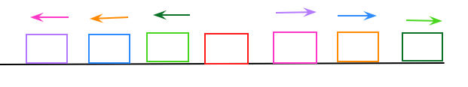
- When finished, the cars should look like this:

(All cars have moved, in order, across the play area to the opposite side)
- You’ll discuss your strategy and let me know what moves to make.

RULES:
- Only one car (arrow) can make a move at a time.
- Cars cannot backup in traffic (cannot move backwards)
- A car can only move into an empty space (and must always be on a space unless making their move to a free space.
- A car can only jump one car at a time and it can’t be a car moving in the same direction.
- There can only be one car on a spot.
- At any time a rule is broken, or if the team is stuck, we will reset. Cars will move back to their original location. No other penalty for resetting.

CONSIDERATIONS:
- Invite team members to unmute, if able, to discuss and plan.

VARITATIONS: (optional)
- Participants could be challenged to only communicate via chat
- Participants could be timed.

