## Steps to Add and Submit a Timesheet Change Request

##### 

Visit [ASSOCIATED STUDENTS OF CALIFORNIA STATE UNIVERSITY, SACRAMENTO - Dashboard > Home](https://secure7.saashr.com/ta/6203977.home?rnd=DJB&showAdmin=1&Ext=login&sft=NSWFZDIZXJ&ActiveSessionId=32881142929#home)

##### 

Click here

##### 

Click on "**Timesheet**"

##### 

Click on "**Change Requests**"

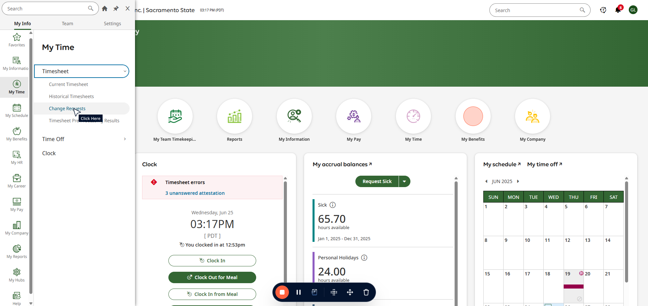

##### 

Click here

##### 

Click here

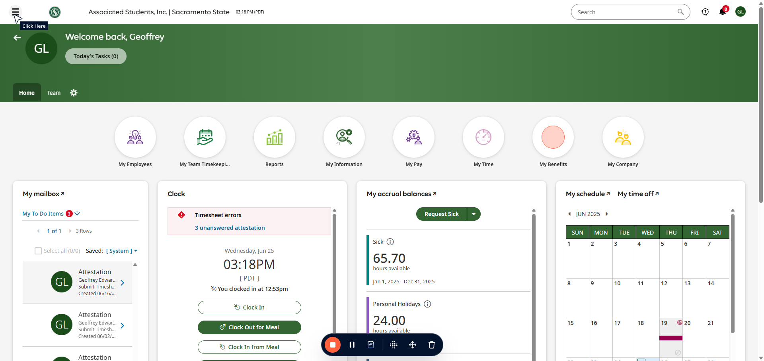

##### 

Click here

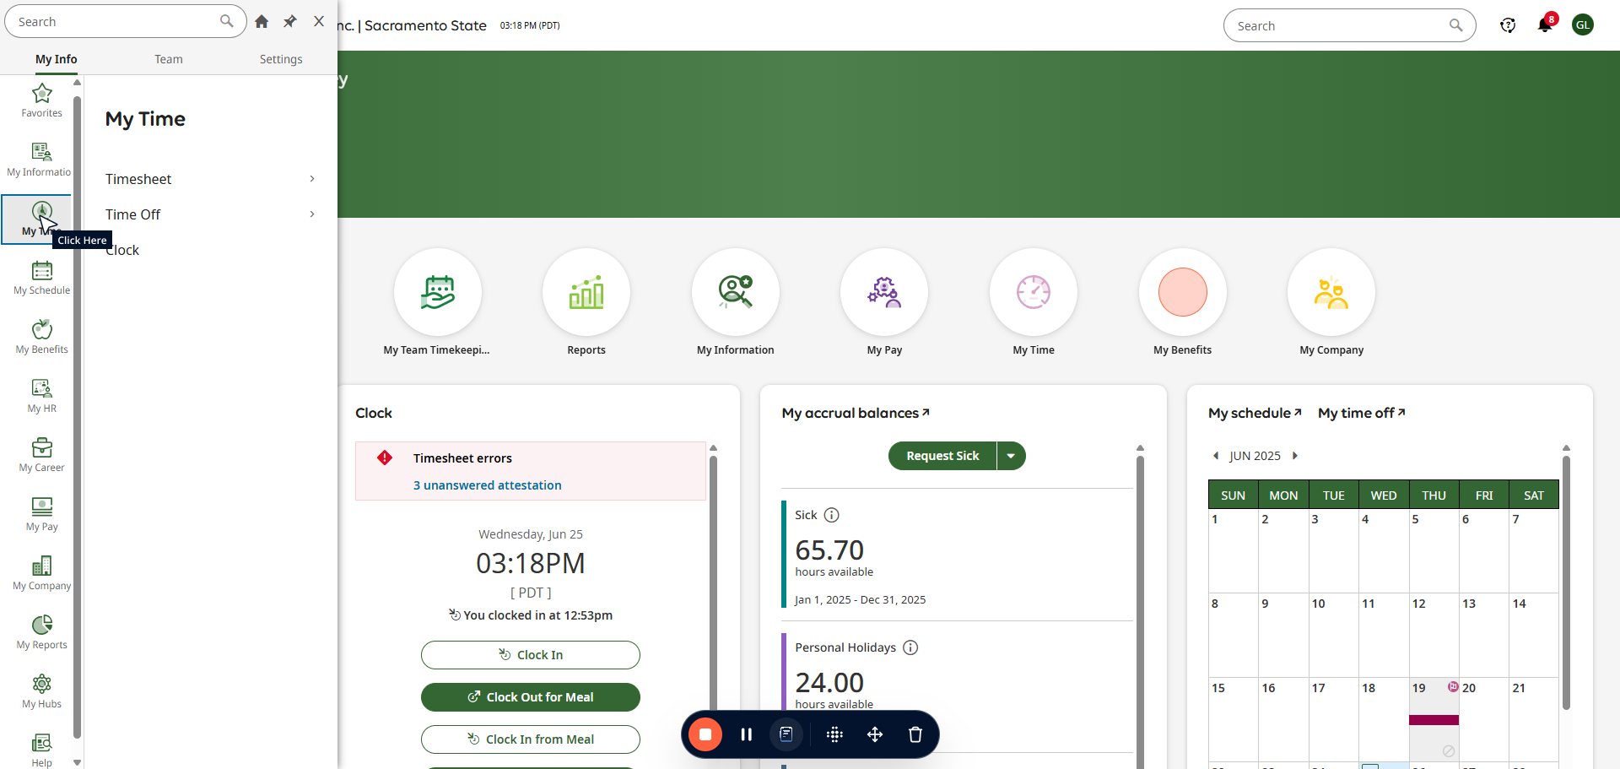

##### 

Click on "**Timesheet**"

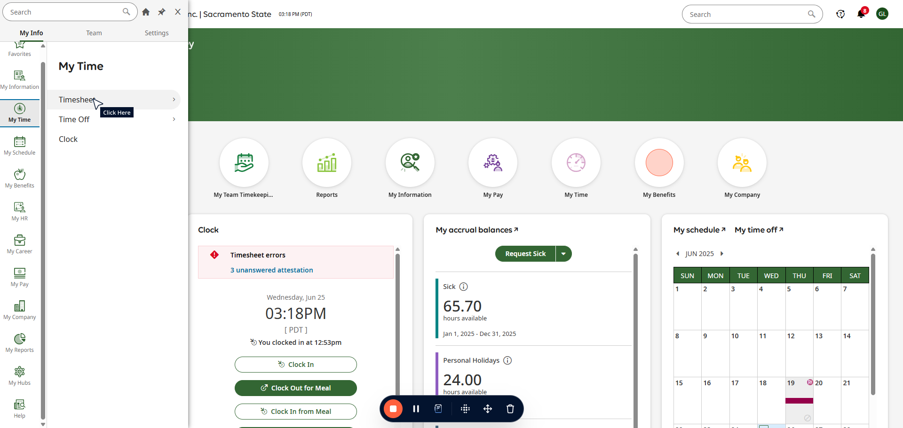

##### 

Click on "**Current Timesheet**"

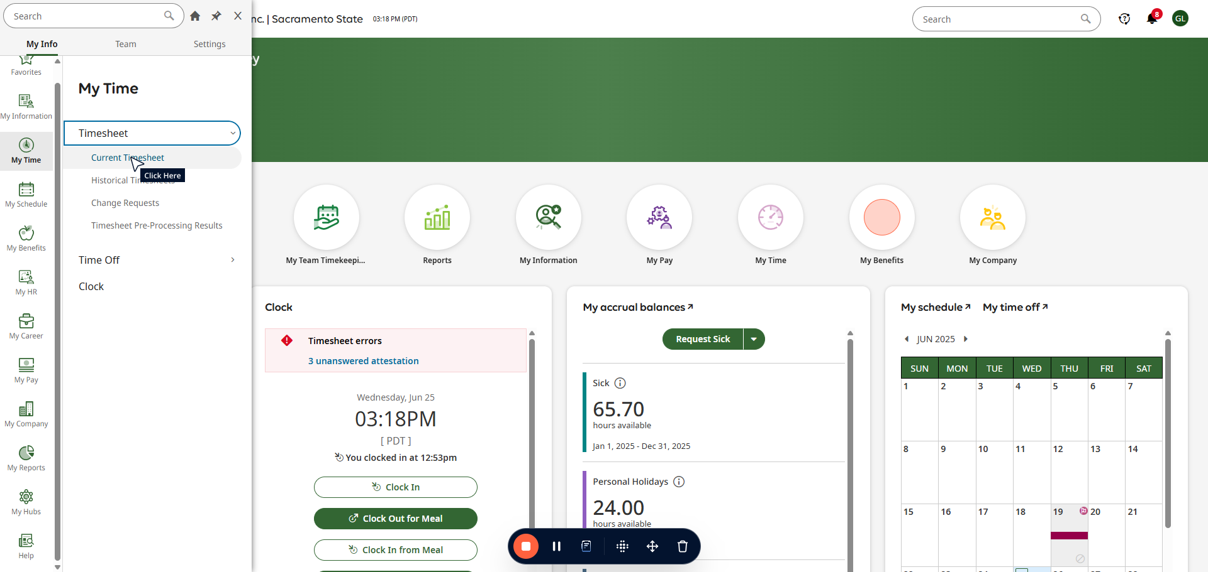

##### 

Click on "**Change Request**"

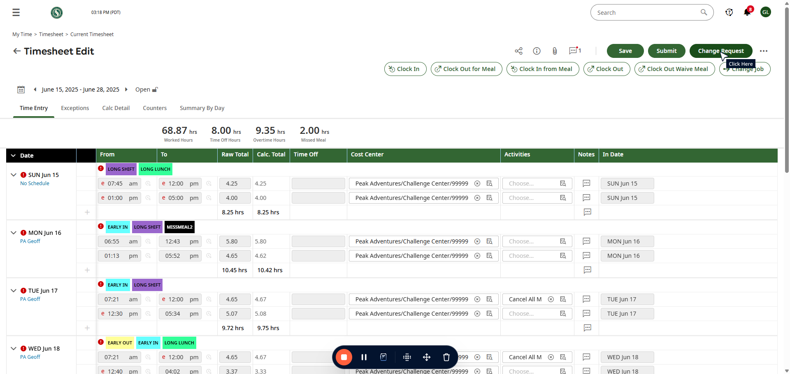

##### 

Click on "**Add Punch In Add Pun...**"

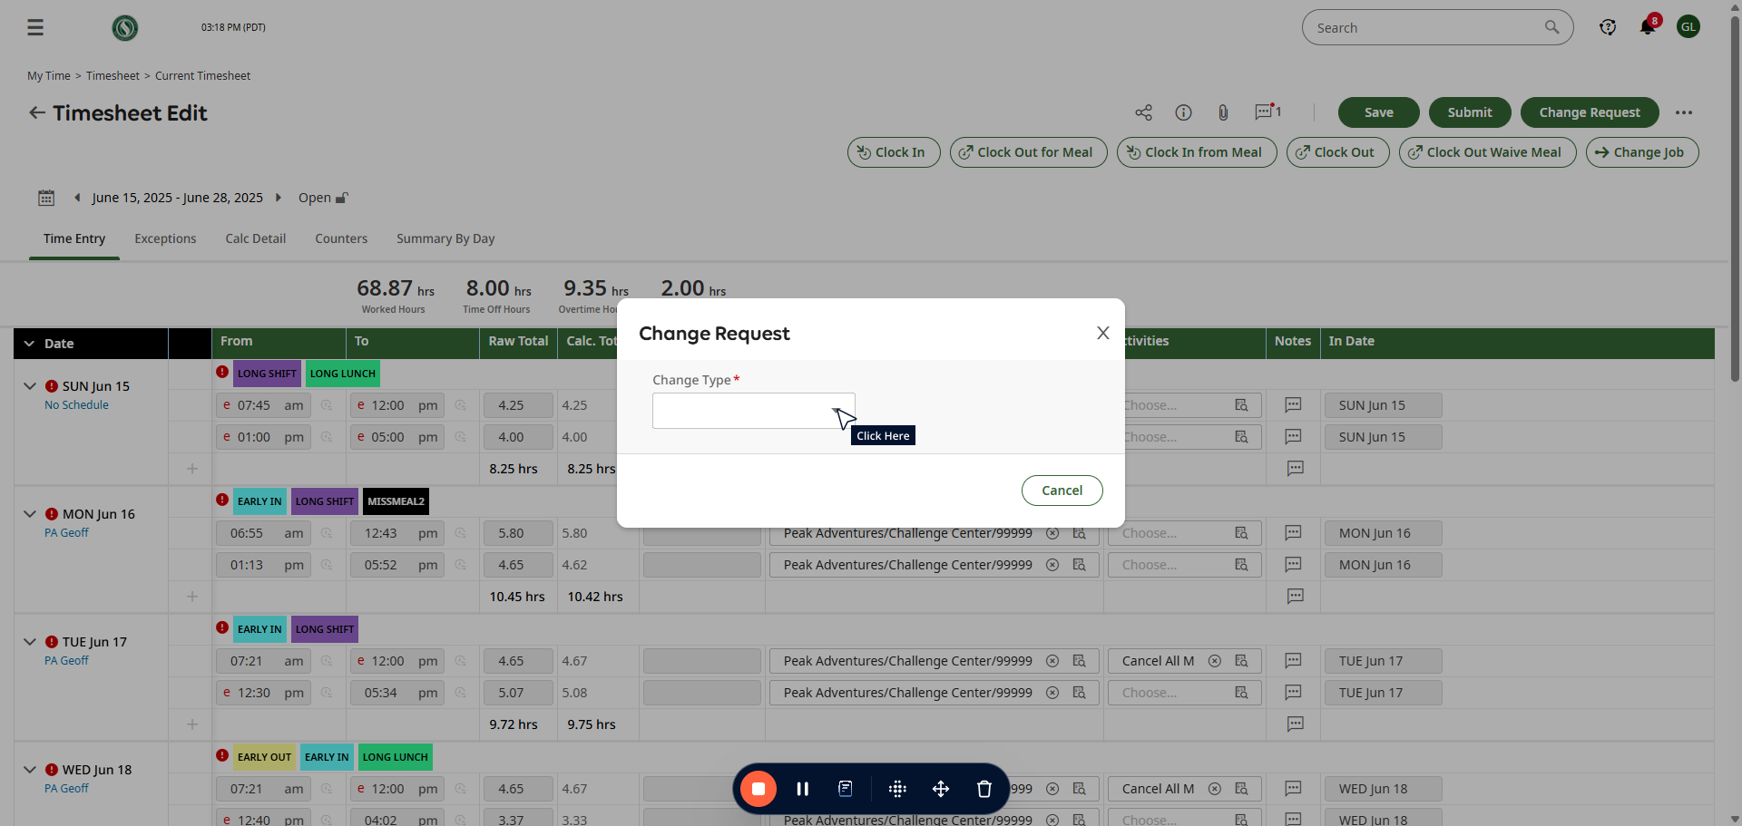

##### 

Click here

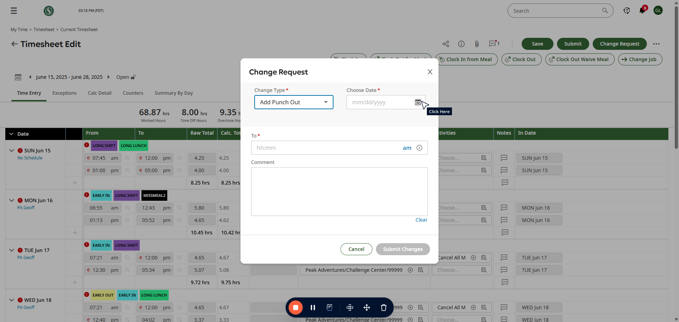

##### 

Click on "**25**"

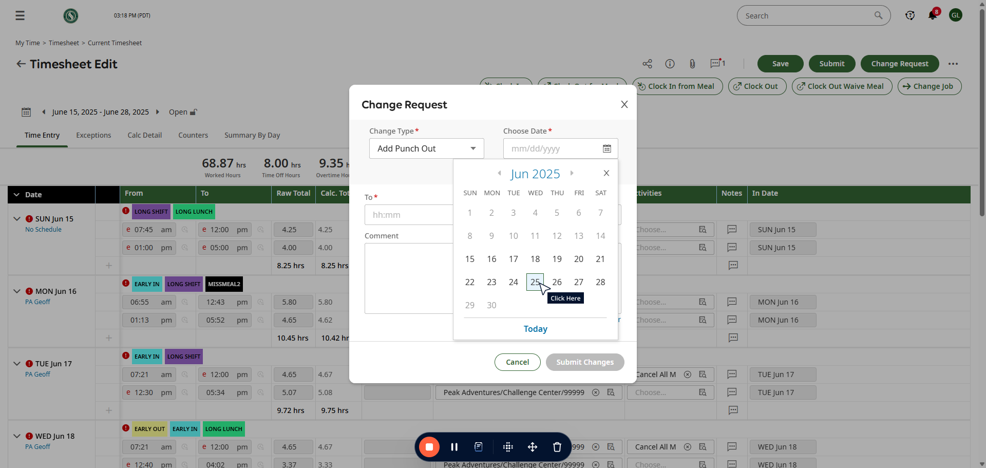

##### 

Click here

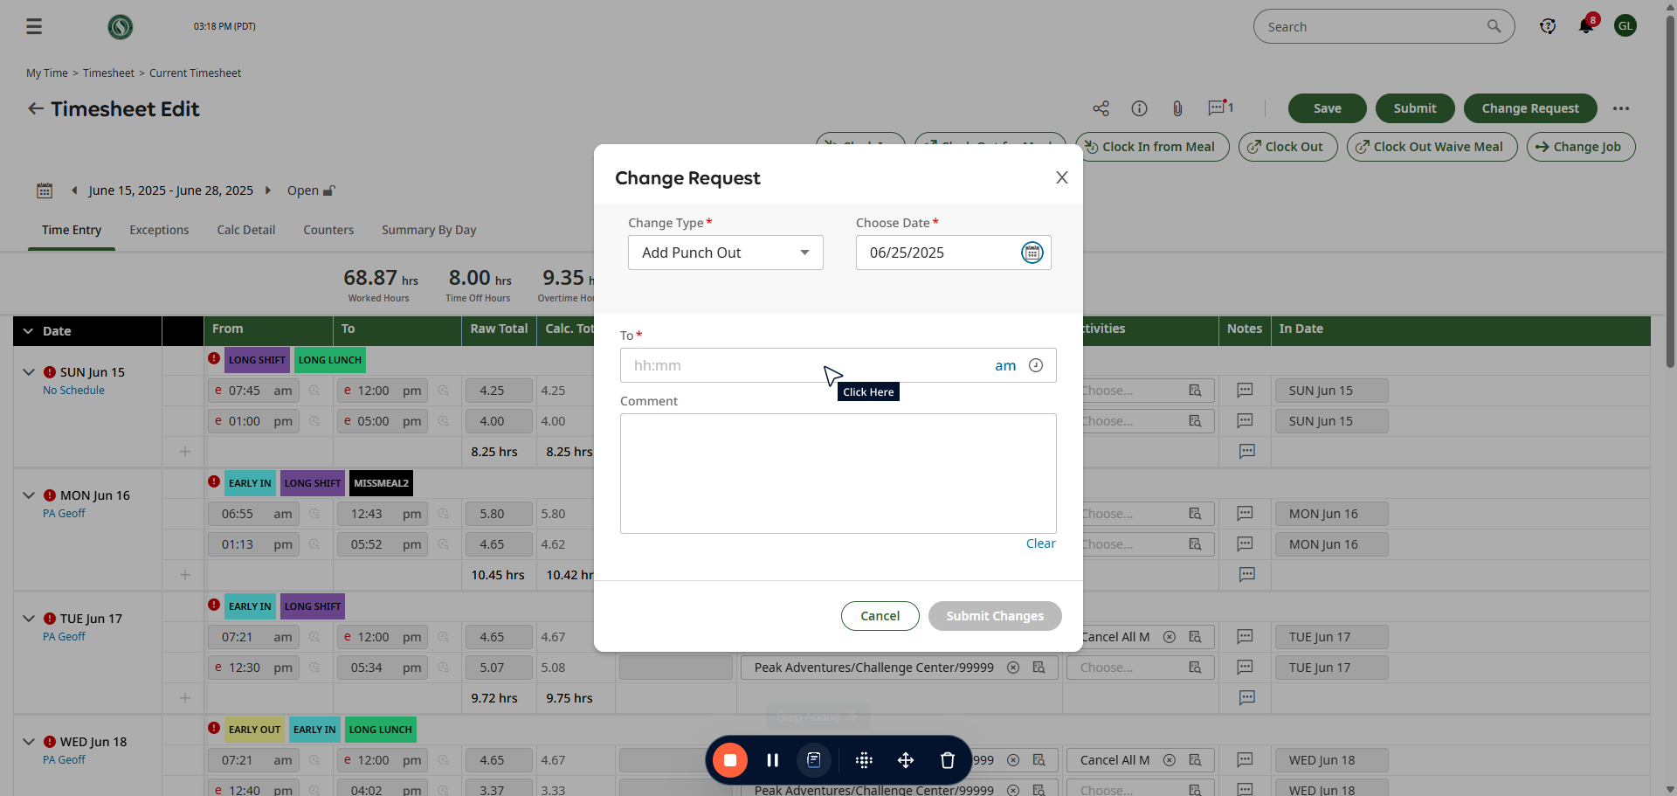

##### 

Type "**318p**"

##### 

Click here

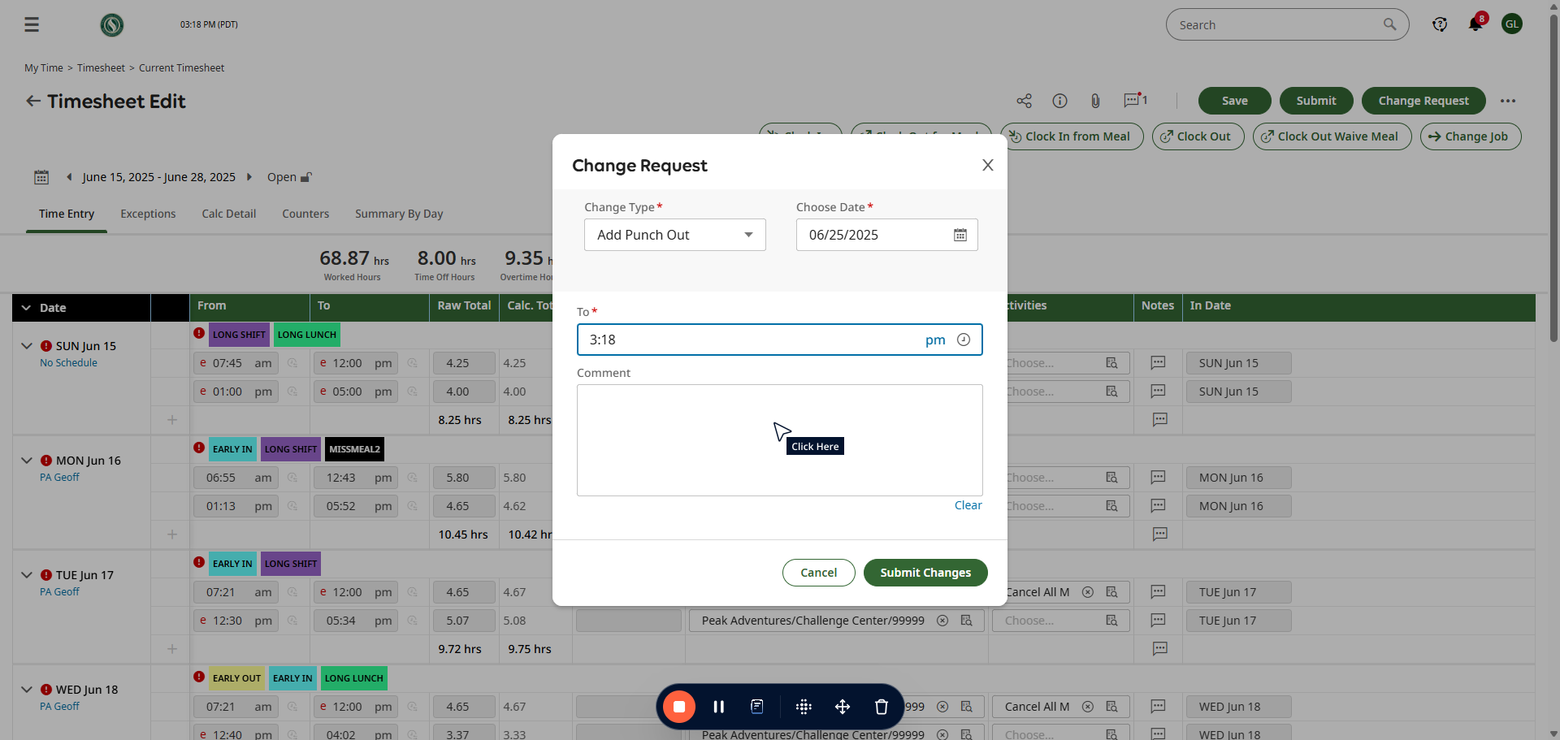

##### 

Type "**clock out test**"

##### 

Click on "**Submit Changes**"

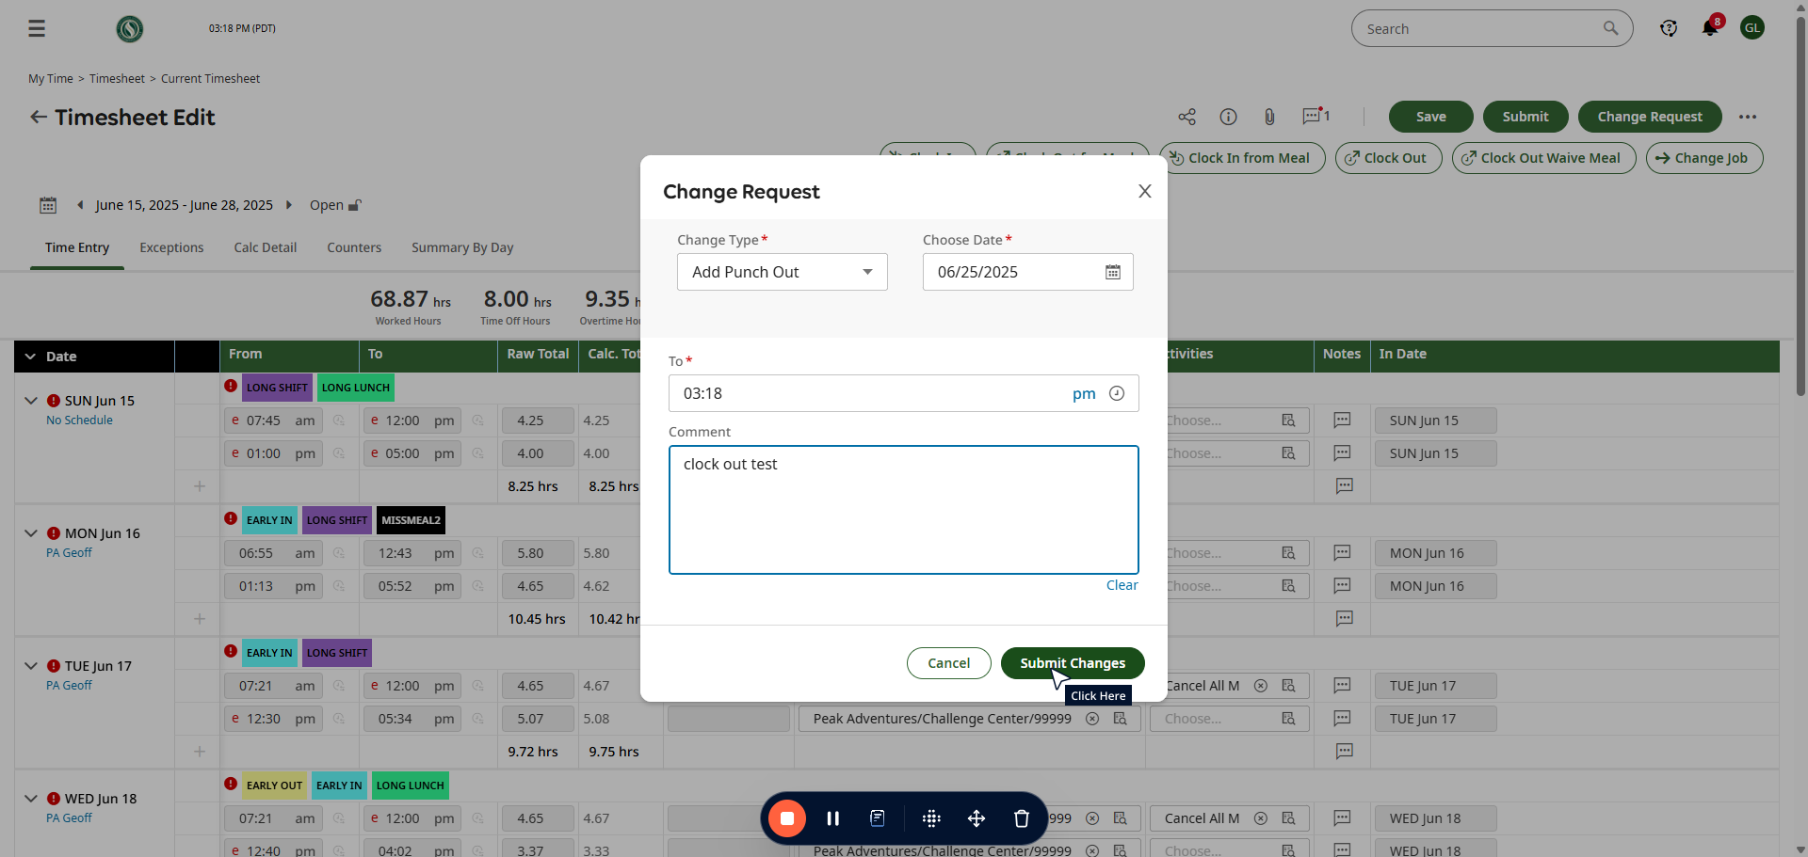

##### 

Click on "**OK**"

