## Setting Availability and Preferences in UKG

##### 

Visit UKG

##### 

Click the Hamburger on the top left of the home page.

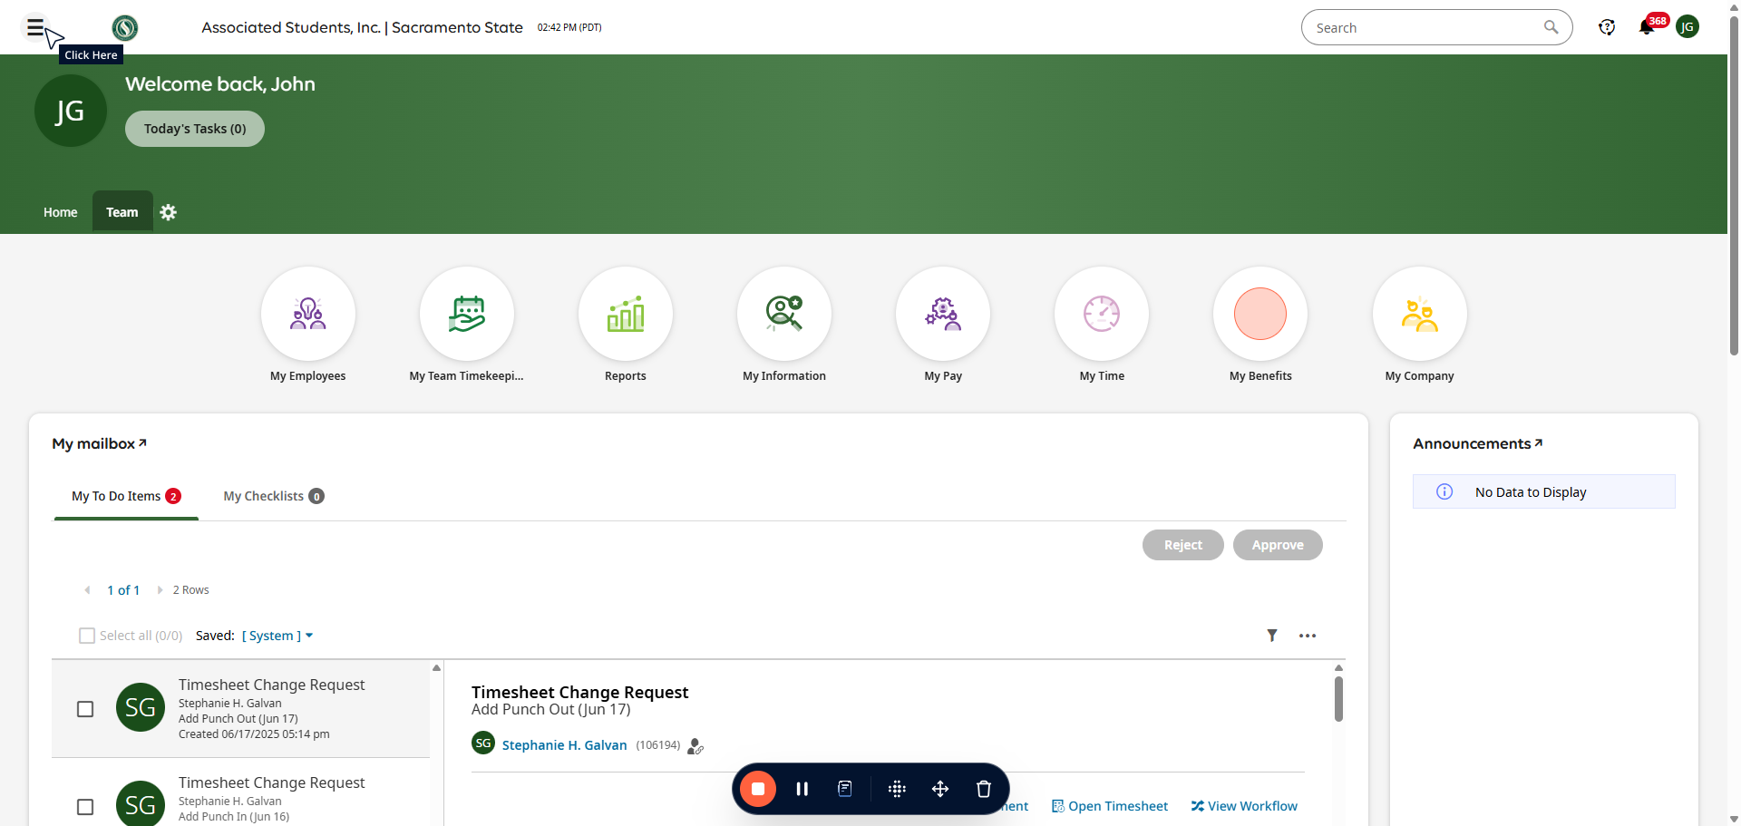

##### 

Scroll down to "My Schedule" and click the "Availability/Preferences" button.

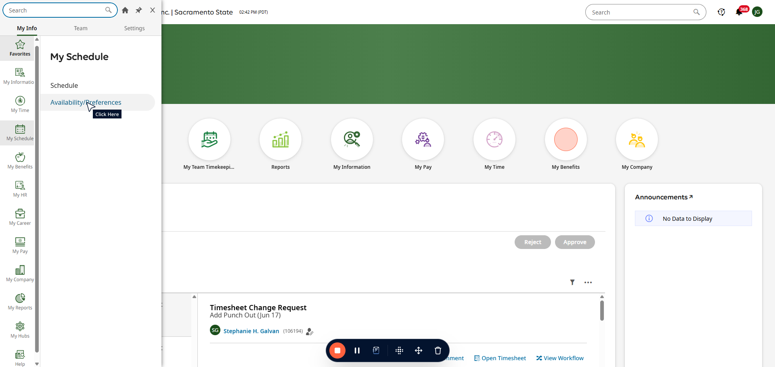

##### 

Choose the days you wish to add your availability on.

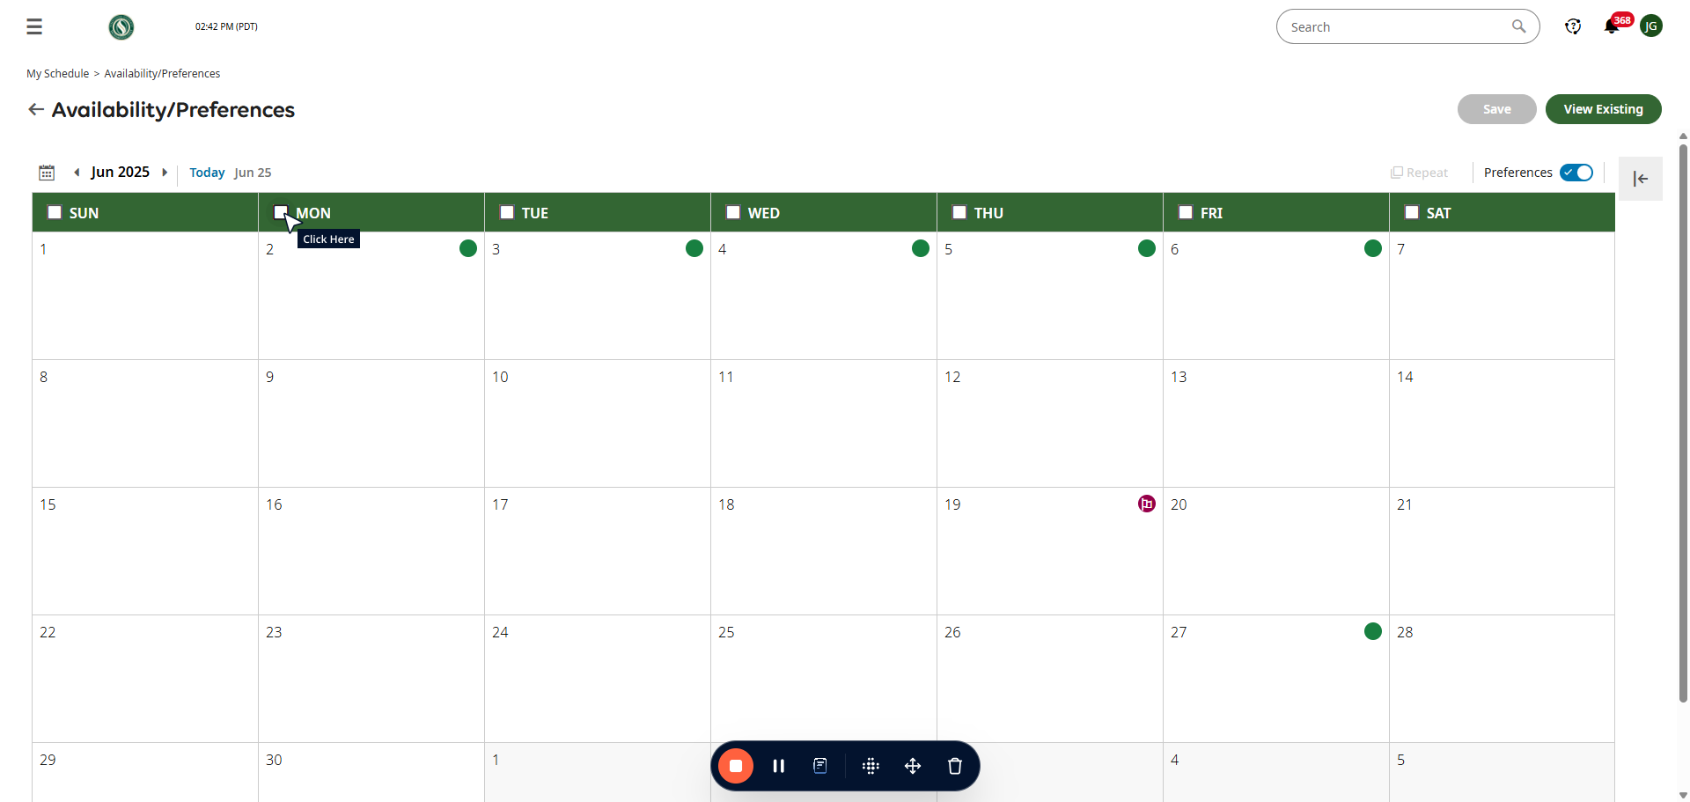

##### 

Input your available times.

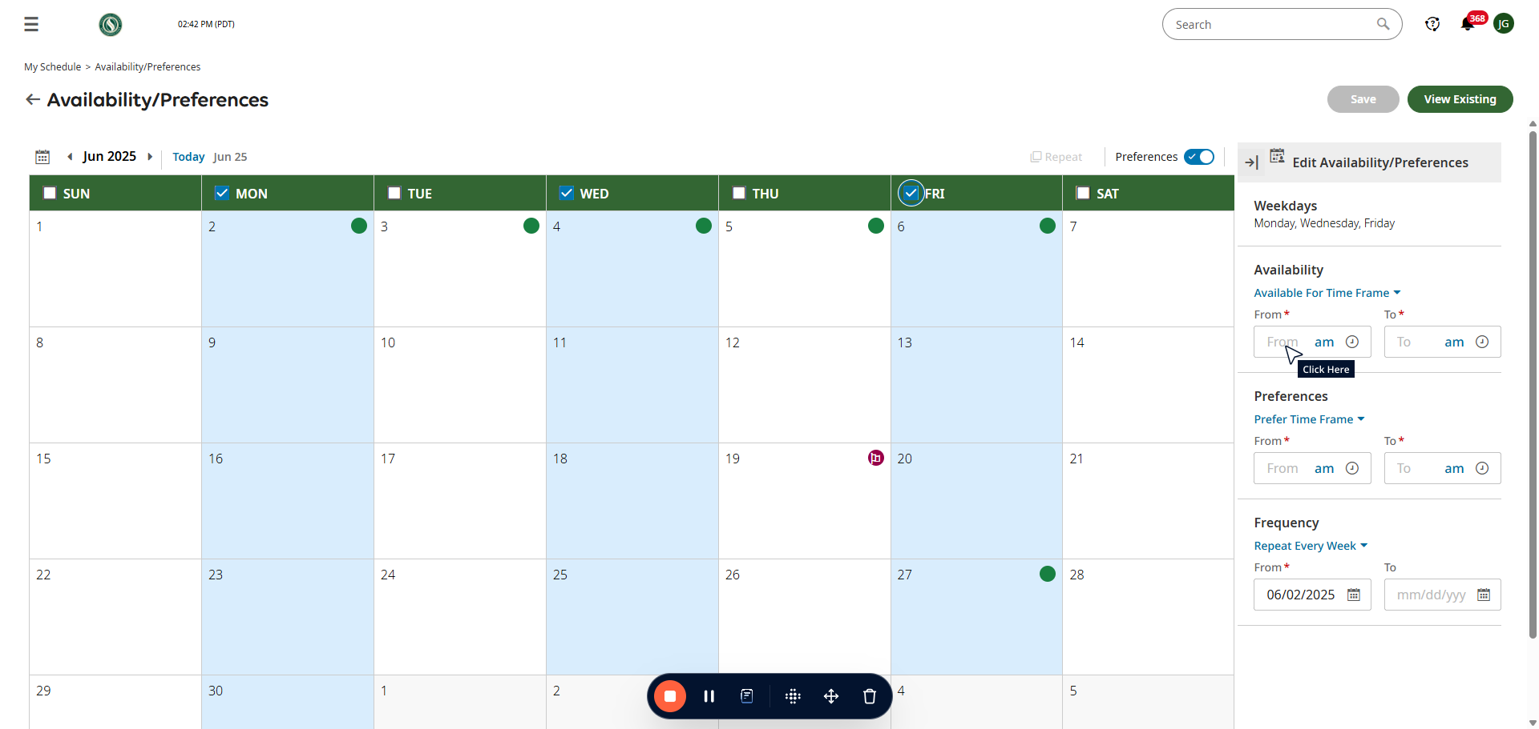

##### 

If you need to add a second timeslot for the same days you can click the "Add" button.

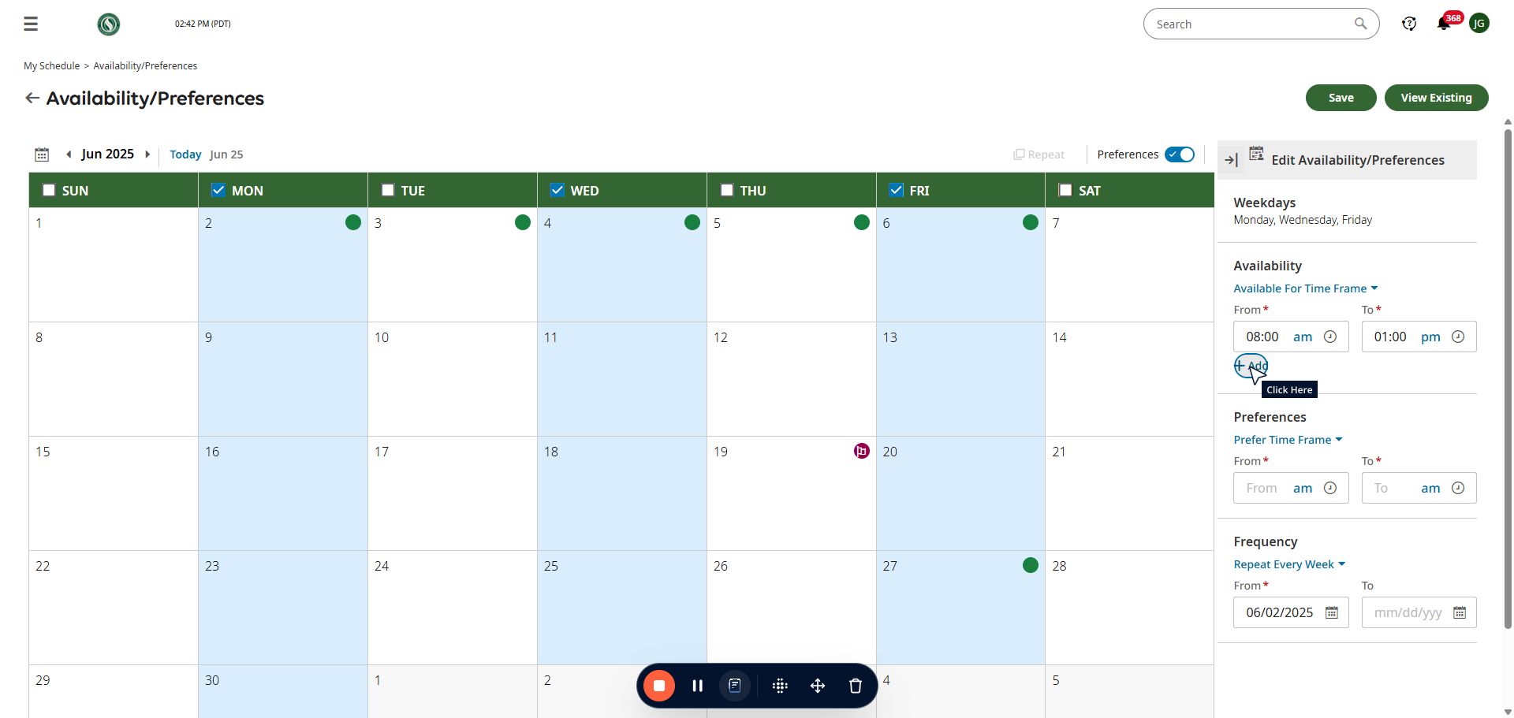

##### 

Under the "Frequency" heading please enter the time frame. The "From" time is the date you updated the availability and the "to" is the date this availability ends. Typically this is the end of the Semester.

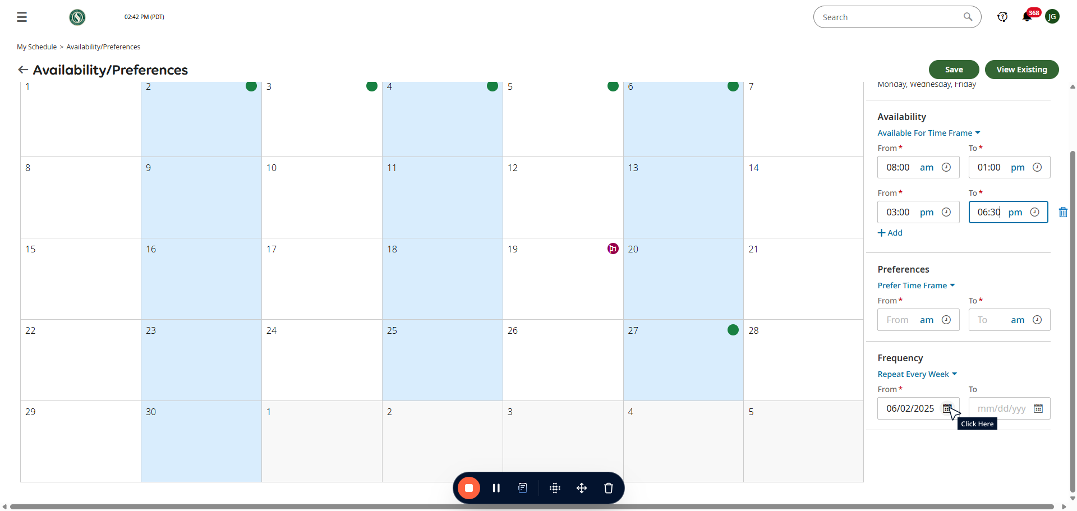

##### 

Once you've done this. Scroll to the top of the page and click Save.

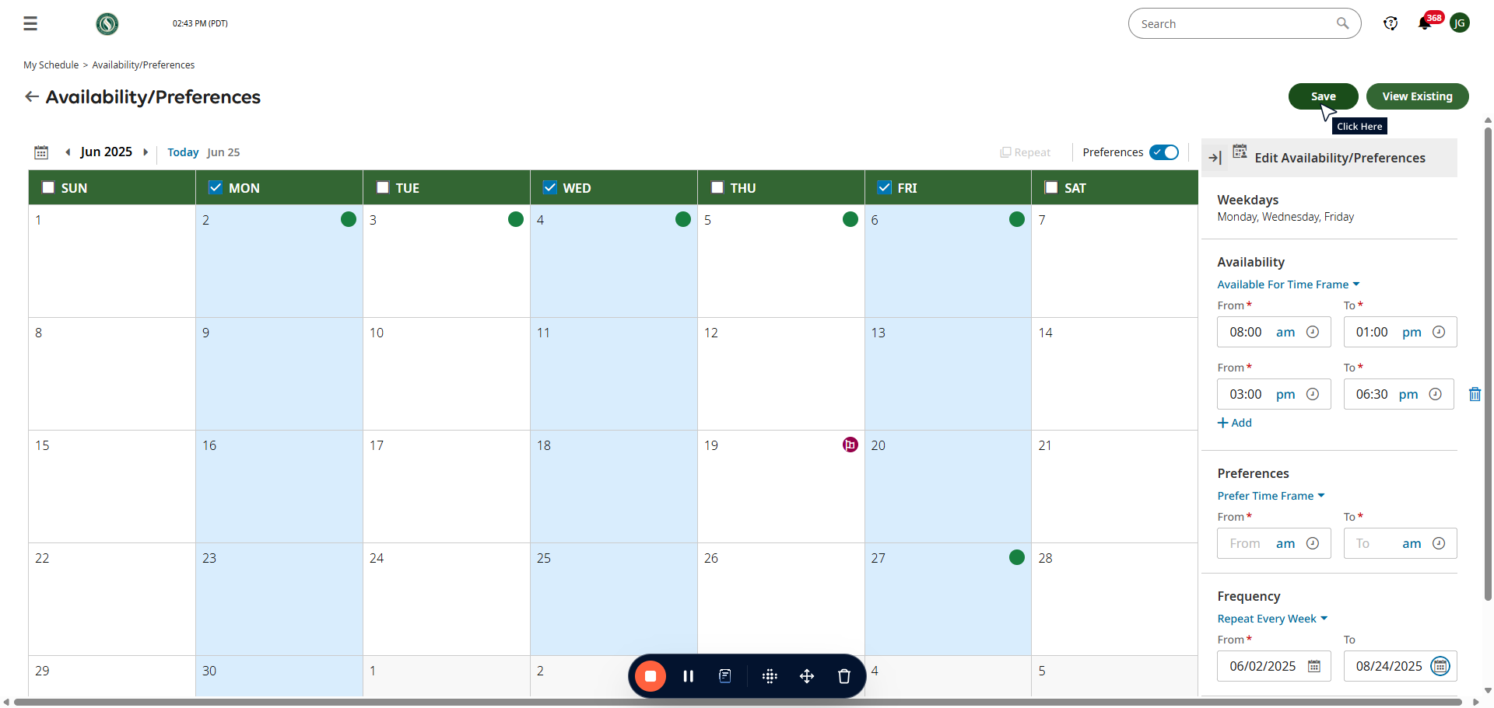

##### 

Repeat those steps for any other availability changes.

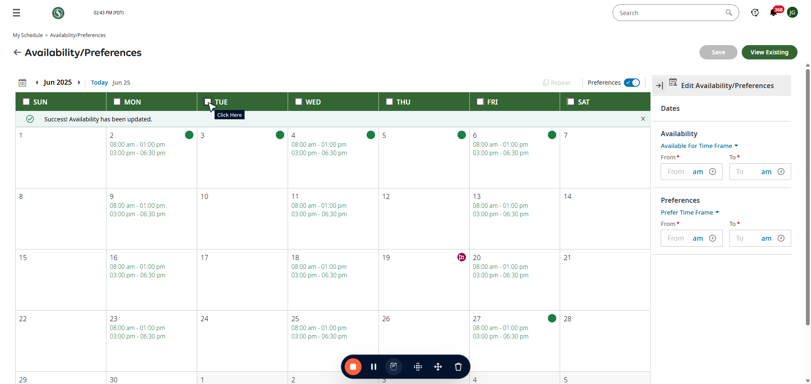

The Challenge Center Manager will Approve or Reject your availability. All Availability changes will go into effect after two weeks of approval.