## Submitting Timesheet Tutorial Steps

##### 

Visit [ASSOCIATED STUDENTS OF CALIFORNIA STATE UNIVERSITY, SACRAMENTO - Dashboard > Home](https://secure7.saashr.com/ta/6203977.home?rnd=KKZ&showAdmin=1&Ext=login&sft=QHGNDRBORI&ActiveSessionId=32881145331#home)

##### 

Click on "**My Current Timesheet**"

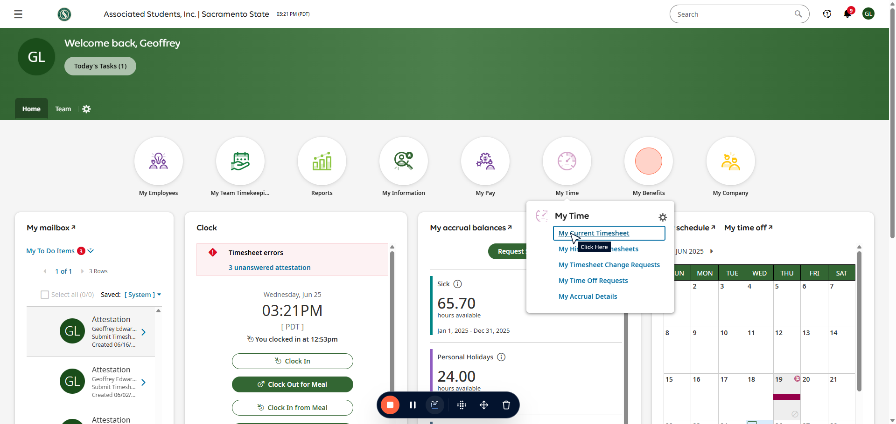

##### 

Review your Timesheet entries for any errors.

1. If you find an error submit a Change Request (see UKG How To Submit a Change Request for guidance).
2. If there are no errors click the “Submit” button on the top right of the page.

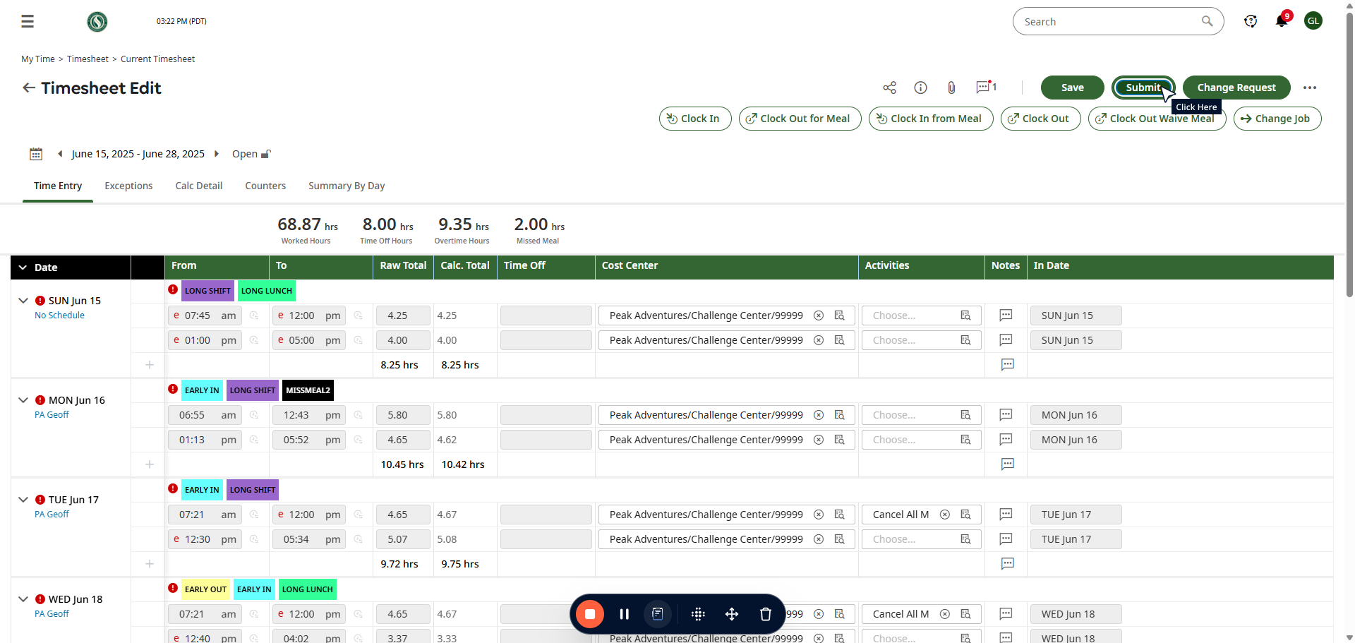

##### 

You do not need to add a comment.

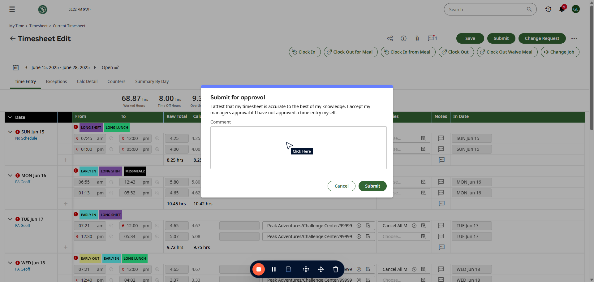

##### 

##### 

Click on "**Submit**"

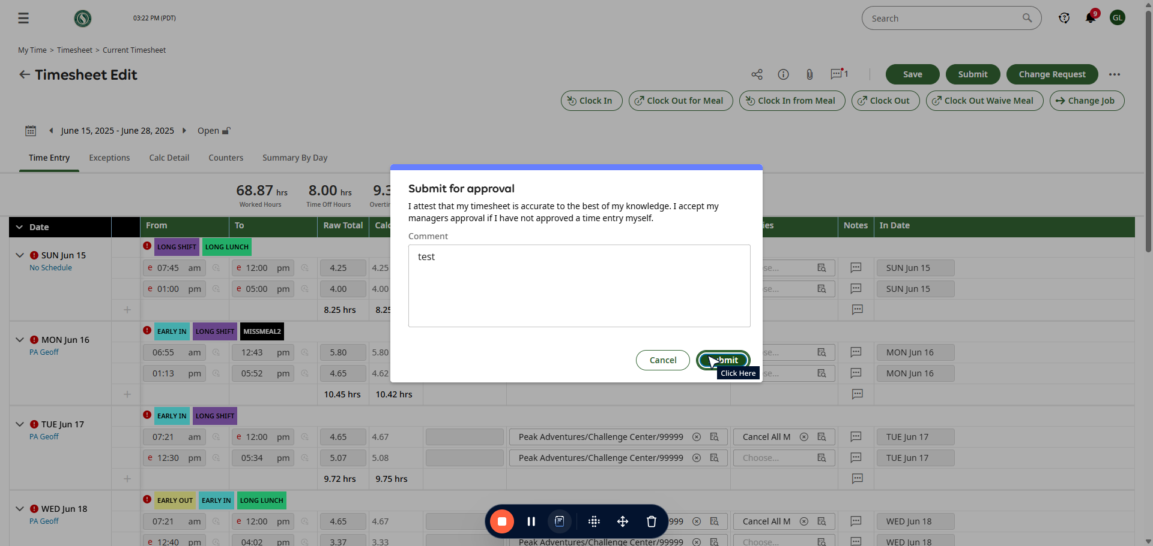

##### 

Click on "**OK**"

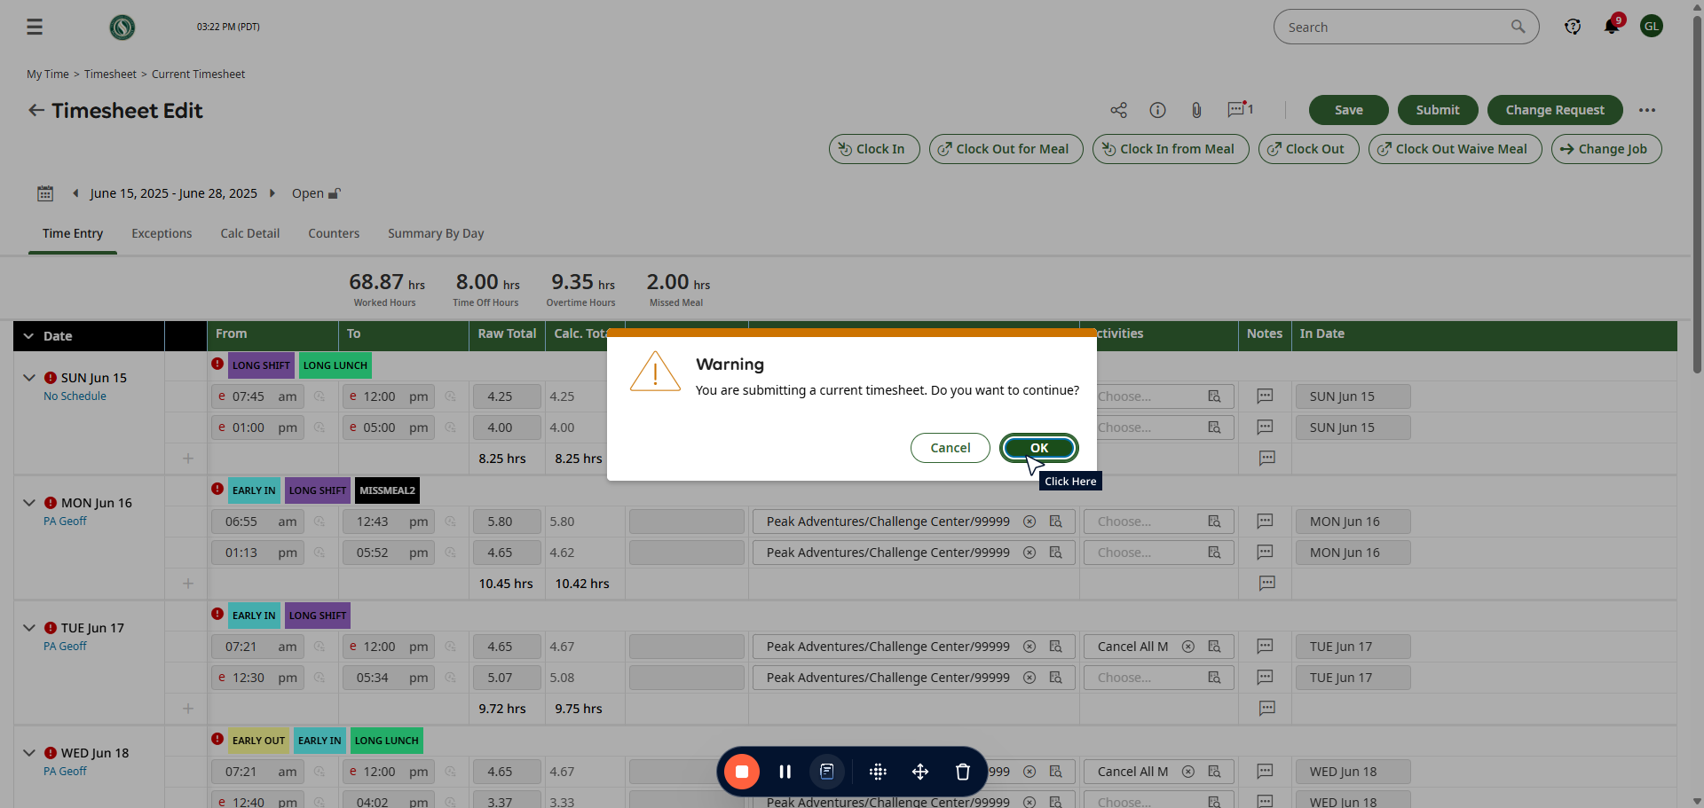

##### 

Click on "**Yes**"

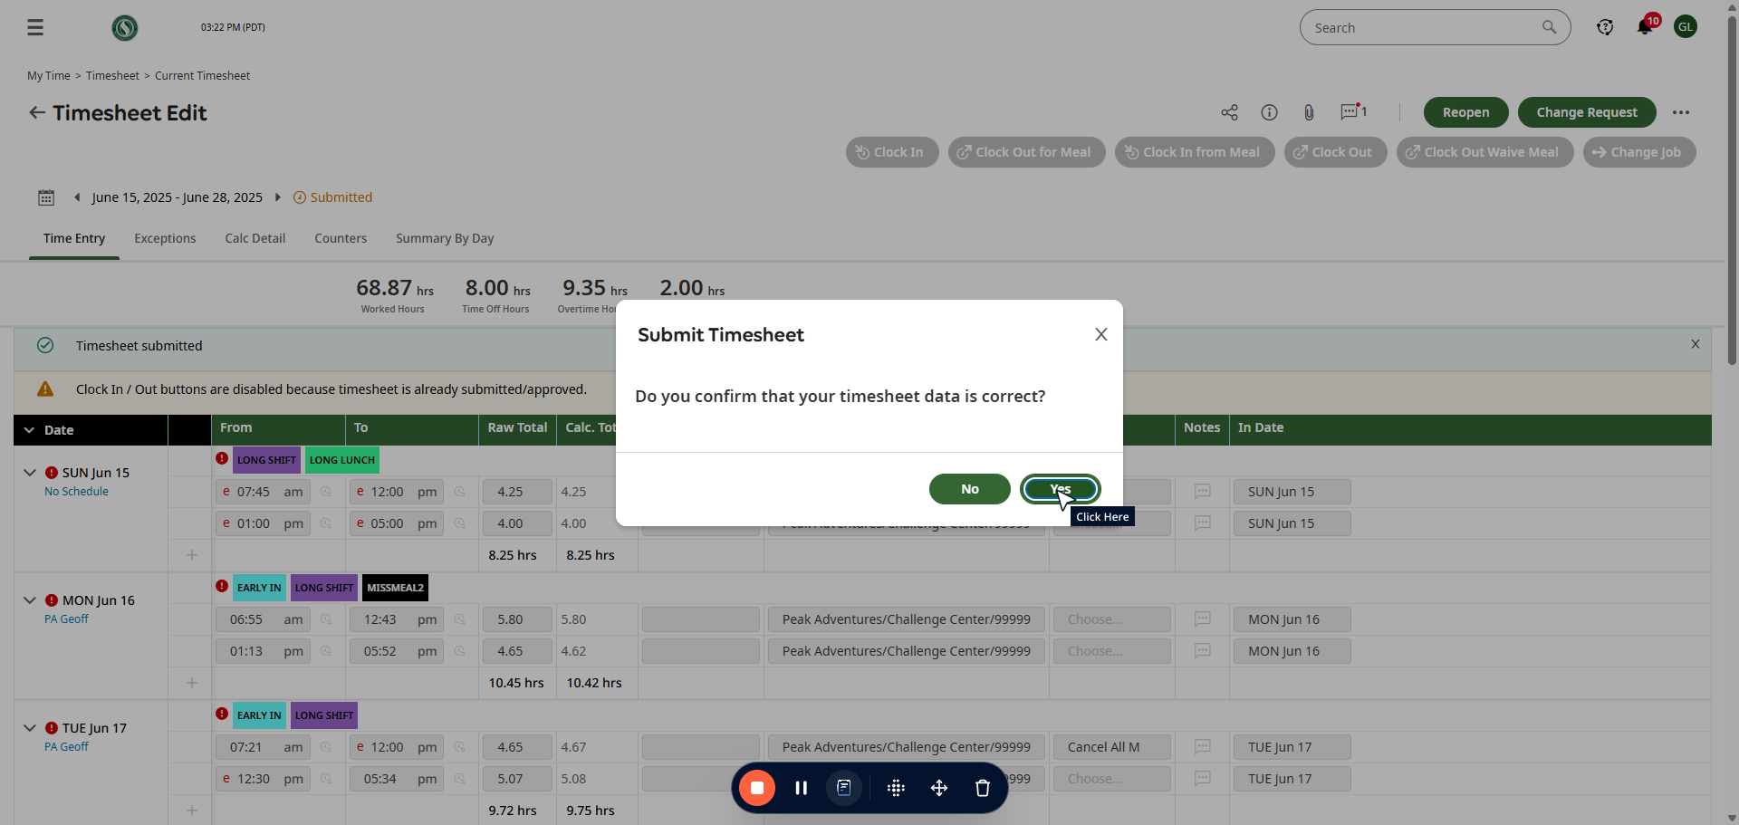

All done!

The Challenge Center Manager will review all Timesheets once more before giving them final approval.